4CS015 Fundamentals of Computing – Workshop #6
TO BE SUBMITTED AS PART OF YOUR PORTFOLIO
Name: FAMILUA ROLAND OLADIPUPO
Student ID: 2326310
This is a marked workshop. You will need to complete the workshop and then submit a copy of this document with a title that follows the following format (“DENNETT 1234567 wsp6.docx”), via CANVAS, by the deadline. The Von Neumann Simulator can be found on Canvas
Workshop tasks:
- Von Neumann Simulator. This program simulates a very simple computer with the von Neumann architecture.
  - Download the von Neumann Simulator (VonNeumann.exe) program from Canvas in the Week 7 topic folder. Save it in your Documents folder and run it. You will see a window similar to this:
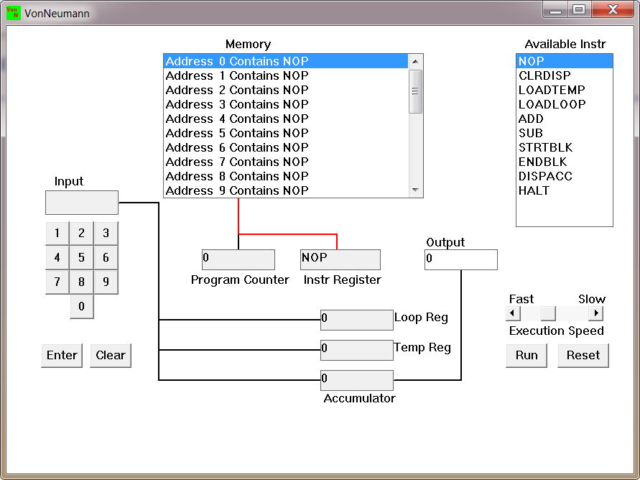
The simulator has a small program memory area which is available for programming. To enter your program instructions simply click on the “Available” instruction on the list on the right and then click on the “Memory” location you wish to put it in.

This simulator understands only the following ten instructions:
NOP | No Operation, i.e. do nothing.
LOADTEMP | Get a number from the keypad, completed by the Enter key, into the Temporary Register.
LOADLOOP | Get a number from the keypad, completed by the Enter key, into the Loop Register.
CLRDISP | Clear the Display.
ADD | Add the Temporary Register to the Accumulator
SUB | Subtract the Temporary Register from the Accumulator
DISPACC | Display the contents of the Accumulator
STRTBLK | Start of Loop Block
ENDBLK | End of Loop Block
HALT | Halt. Stop Program

  - Load the following program into the memory:
LOADTEMP
ADD
DISPACC
HALT
To do this, first click on the “LOADTEMP” in the list of instructions on the right of simulator window. Then click on Memory location with “Address 0 Contains NOP”. This will then change into “Address 0 Contains LOADTEMP”. Repeat the process with “Address 1” and so on until the whole program is loaded.
  - Run the program by clicking on the “Run” button. The simulator would highlight the Address 0 location and then pause. It is executing the instruction “LOADTEMP” which requires you to input a number into the keypad.
Click 2 or 3 numbers on the keypad and then click the “Enter” button. The simulator will then resume running the program and execute the instruction “ADD”. This adds the number that you just entered, to the zero in the accumulator.
The next instruction is “DISPACC” which stands for “Display Accumulator”, and it does exactly that. After than the simulator stops running the program when it executes the instruction “HALT”.
  - Load the following program into the simulator:
LOADTEMP
ADD
LOADTEMP
ADD
DISPACC
HALT
What do you think it does? Write your answer below (10 marks)
THE PROGRAM ABOVE IS USED TO ADDED TWO NUMBERS TOGETHER, LOADTEMP ALLOWS YOU TO INPUT A NUMBER TO THE PROGRAM, WHILE ADD OPERATION ALLOWS YOU TO add .REPEAT THE SAME TWO OPERATORS TO ADD THE SECOND NUMBER . DISPACC ALLOWS YOU TO DISPLAY THE OUTPUT AND HALT STOPES THE PROGRAM
  - Write a program to add 3 numbers together. List your program below (10 marks)
LOADTEMP
ADD
LOADTEMP
ADD
LOADTEMP
ADD
DISPACC
HALT
  - Write a program to subtract a number from another. List your program below (10 marks)
LOADTEMP
ADD
LOADTEMP
SUB
DISPACC
HALT
  - Load the following program into the simulator:
LOADTEMP
ADD
LOADLOOP
STRTBLK
ADD
DISPACC
ENDBLK
HALT
Run it and when it reach the LOADTEMP instruction, enter 5 on the keypad and click the “Enter” button. When it reaches the LOADLOOP instruction, enter 6. What do you think the program does? Write your answer below in the form of an equation (10 marks)
LOADTEMP IS USED THE INPUT THE MAIN NUMBER AND THE FOR ADD WILL ADD IT WITH THE SECOND NUMBER , WHILE LOADLOOP IS THE SCRIPT USES TTO REPEAT THE LOADTEMP till it reaches 0 , so for the example given the 5 is the load temp and the load loop is 6 while the start block is used to start the loop and ENDBLK is used to end the loop
THE EQUATION (5*6)+5=35
  - Write a program that will let you add 5, or 10 or 20 numbers together. List your program below and explain how it works (25 marks)
LOADLOOP
STRTBLK
LOADTEMP
ADD
DISPACC
ENDBLK
HALT
NOTE THAT The aim of these program is to help add 5, 10,20 or unknown numbers together (x) first the number of values that will be added is LOADLOOP THEN THE LOOP WILL BE STARTED BY STRBLK.THEN WE ADD THE NUMBER WE WANT TO ADD WITH .AND HELPS WITH THE FUNCTION. NOTE THE DISPACC WILL DISPLAY THE OUTPUT AND THEN THE END BLK STOPS THE LOOP HALT TEHN STOPS THE PROGRAM
  - Write a program that will let you multiply 2 numbers together. List your program below and explain how it works (35 marks)
LOADLOOP
LOADTEMP
STRTBLK
ADD
DISPACC
ENDBLK
HALT

THIS PROGRAM IS A BIT DIFFERENT FROM THE PRIVIOUSE PROGRAM (i) HERE THE LOAD TEMP IS BEFORE THE STRTBLK BECAUSE WE INSERT THE TWO NUMBERS WE WANT TO MULTIPLY FIRST THAT’S LOADTEMP AND LOADLOOP THEN .AND HELPS WITH THE FUNCTION. NOTE THE DISPACC WILL DISPLAY THE OUTPUT AND THEN THE END BLK STOPS THE LOOP HALT TEHN STOPS THE PROGRAM

